APHEO Health Equity Working Group
Tuesday March 25, 2025
10:00AM – 11:30AM

Attendees
Members:
Regrets:
Agenda
Item | Topic | Lead
1 | Welcome and introductions | Trevor van Ingen
2 | Sociodemographic data collection working groups | Samiya Abdi
3 | Planning for next meeting | Trevor van Ingen
4 | Open discussion – what are you working on? | All

Item 2: Sociodemographic data collection working groups
Samiya Abdi: The PHU SDD Community of Practice is a parallel group:
- Create a space for people working on this file. A number of working group members are also a part of this working group. It is a space for learning and sharing.
- The group is specifically for PHUs, with different roles (eg managers, knowledge exchange specialists, epis) but includes and some academics. For those interested and immersed in sociodemographic data collection practice. The group has discussions about data collection and community data governance.
- Have a PHU Sharepointe site for documentation and a discussion board
- They meet quarterly, met last Friday
- Can share that the APHEO Conference, with a lens on health equity, is happening
- If anyone wants to join the PHU SDD Community of Practice, you can email Samiya

What to do with parallel working groups?
- Feels like there is overlap between the groups. Do we need both groups?
- Some feeling that our discussion could better fit at the community of practice.
- What is PHO's vision for sociodemographic data collection? Samiya: Perhaps training and consultation about plans
- Often the training has to be very specific to the context of the service.
- The amount of resources/time needed for data analysis is small compared to other components of the process.

- A prioritization exercise at the last PHU SDD CoP identified community data governance came up as an area for training.
- PHO does not do advocacy, but the community of practice can put forward something.

An example of an advocacy letter for SDD collection:
https://cdn.ymaws.com/www.alphaweb.org/resource/collection/8732D26A-679B-4AB9-9C50-532E0CC3A278/alPHa_Letter_SDD_Collection_141022.pdf

CanChek: a data system that StatCan promotes. PHUs don't have access
If we can't collect SDD through OHIP, there are other things we can do.
Virtual Space

From Ottawa, regarding the SDD collection and reporting process:
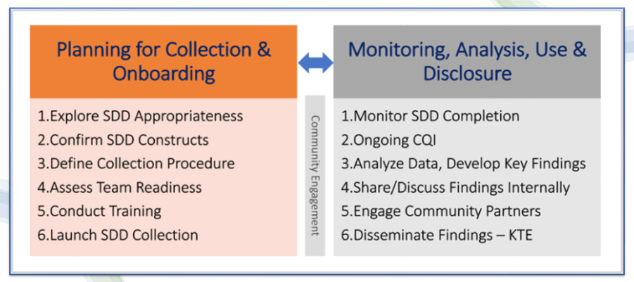

Indigenous Data Governance - can this be done on behalf of PHUs by PHO?
Perhaps this group can be more focussed on analysis of the data?

Laura Zettler, Aideen, Laurie are or will sit on the Community of Practice group.

- A New Chair is needed: Trevor has been the chair for almost 2 years. Trevor will be on parental leave end of April until end of August.

- Next meeting: Meetings are usually the last Tuesday of the quarter at 10am
ACTION: Caroline will send out a meeting invitation for Tuesday June 10th and Trevor will book a couple Tuesdays for later in the year.

- Community Data Governance (Greg)
This topic could fit with the CoP. Some people at Peel are thinking through this. Do any PHUs currently have a table for this topic? Megan: specific for Indigenous data - have secured Nicole Blackman from the Indigenous Primary Health Care Council to speak at the conference Meet The Team - Indigenous Primary Health Care Council and they actually have a mandate to speak to PHUs about.
Ottawa - In absence of a "table" per se - we are having conversations with different communities about data governance and how to honor EGAP and OCAP. Communities are aware of what we are doing (i.e. collecting SDD) - we are collecting on behalf of communities and we are engaging communities to help us interpret the data and control how and with whom we share.

There doesn't seem to be a PHU that is a clear leader in navigating data governance.

Ottawa: We try to stay true to this home-grown framework for the SDD journey

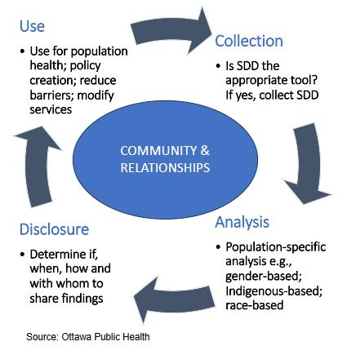

Can PHO help set up data governance tables?

Caroline: met with Ontario Health Team and asked about Indigenous data governance. Cancer Care Ontario might have something?

Shared link:
https://familymedicine.queensu.ca/sites/familymedicine/files/inline-files/Toolkit%20-%20Indig-Focused%20Approaches.pdf

PHO - doesn't report Indigenous health data. Have a new director of Indigenous engagement and strategy.

APHEO Repro Child Health Group - putting an ICES request for therapeutic abortions. The timeline for the request hinges on a process that involves Indigenous consultation. They may have some advisory panels. Maybe they have some examples of their process that they can share?
https://www.ices.on.ca/indigenous/

Niagara have an Indigenous health specialist on staff.

Think about it being reciprocal - what can be brought? What are their needs and priorities?
Engagement is necessary and not an epi roll.
The process is slow and complex and will take time.

