Geocoding of Addresses versus the use of Postal Codes
Postal Code Geo-Referencing in Ontario

The use of 6 digit postal codes to map health data has been implemented widely in Ontario. The primary advantage of using postal codes as a geo-reference is that it is a quick and easy way to map out large datasets, often consisting of millions of records. Postal codes are an excellent way to quickly and accurately map in large urban areas where a postal code will usually translate to corresponding with a block face (single side of a city block). For most purposes this represents a sufficient locator, but the effectiveness of mapping to postal code quickly becomes problematic in smaller towns and rural areas, where a single postal code can cover a very large geographic area that often extends across multiple municipalities and health unit boundaries. The over reliance on postal codes to map in both public health and health planning results in poor representation of rural and small towns in health data.
The main purpose of postal codes is to deliver mail, not map populations. Addresses are assigned to a post office for mail delivery, and that post office may be located in a different municipality, and as a result a mailing address will indicate that an address is in a different municipality than the physical property. In addition in some regions Canada Post makes use of a centralized mail boxes, general delivery, or utilize a rural route that does not conform with common street names and emergency locators. Finally postal code data are considered proprietary by Canada Post, who expect financial compensation for the use of postal code data.
Postal codes do not conform with Standard Geographical Classification (SGC), which is a standardized hierarchical classification system for geographic data in Canada and internationally. Therefore, data collected at a postal code level are not directly compatible with other statistical data in Ontario such as census data. In major urban area where a postal code fits neatly inside a Statistics Canada boundary such as a Dissemination Area (DA), it may be possible to summarize postal code data. However, in rural areas a single postal code may be spaced out across 30 or more DA’s and cross multiple municipalities and health unit boundaries. In any situation where the singular relationship between a postal code and SGC is lost, the data loses value exponentially.
Lack of denominator data, there is no supporting data available at a postal code level, as again the purpose is mail delivery not population demographics or statistics. For example to calculate the vaccination rate becomes a challenge if data cannot be readily linked to denominator data
To address the issues of rural postal codes a product called PCCF+ is widely used that weights postal code points based on the proportion of the population that lives at that point. However, this is purely speculative, and cannot be used to accurately locate a specific event such as the location of a case or vaccinated individual. As a result postal code mapping leads to over/ underestimation of counts by dissemination area.

Constantly evolving/ data updates

Addresses do not match the municipality of where address is located, particularly an issue on the edges of areas. In WDGPH within our boundary we have properties that use address from Cambridge, Elmira, Wallenstein, Acton, ….We also have events assigned to WDG that are actually located in other areas.
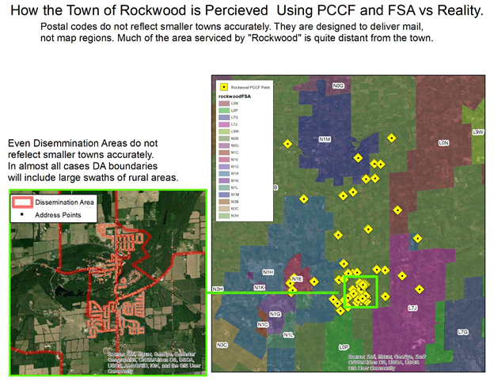

FSA should never be used for geolocating outside of major urban areas, the issue of postal codes is amplified when further generalizing to FSA. See image below that depicts the 17 municipalities that comprise of WDG and the corresponding FSA boundaries of FSA’s that are located within WDG.
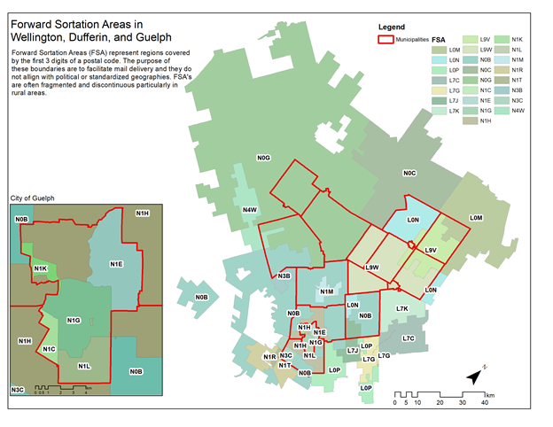

Mapping by address
Benefits
• Precise location that can be consistently translated to SGC boundaries
• Allows for visualization of localized hotspot areas
• Enables insight into rural areas, which are currently exhibiting much lower vaccination rates than urbanized areas
• Eliminates mis-classification of cases and vaccinations to incorrect health unit
• Reduces health inequalities currently experience by rural populations
Issues with address
• Very sensitive to spelling and data entry inconsistencies when geocoding
• Lack of universal address points in the public domain (Province does have access to complete address listing), not all health units have access. Health Units are not able to access Land Information Ontario data.
• Alias street names (streets that may be referred to by different names i.e. Yonge St / Highway 7) can present an issue
• Labour intensive, and does require access to qualified GIS staff and expensive software. Many health units do not have this capacity internally, and not all have singular municipality to call on for assistance. The major urban health units are the more likely ones to have access to either internal or municipal GIS resources.
• Mailing address inconsistencies post office vs municipality
• Use of centralized post boxes, mailing address is not the same as emergency services locator. Most provincial systems ask for mailing address and assume that it is the same as property location.
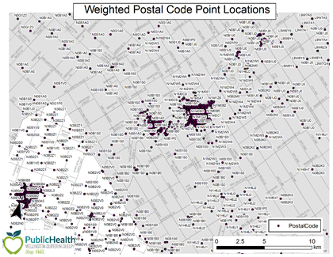
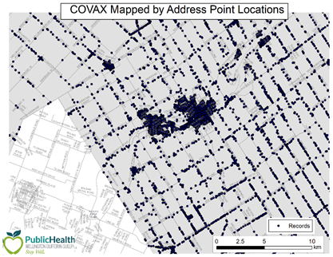

Suggested Solution
Use of a hierarchical geocoding model, address, road network, postal code. Use geocoded addresses to assign SGC such as DA, CSD. The most useful SGC for health regions is usually the DA, as it is small enough to gather useful spatial insight, and can also easily be scaled up for statistical and privacy purposes.
Spend time on building accurate composite geo-coders that can accommodate a variety of spelling variations and alias named e.g. Dufferin County Road 7, County Road 7, Dufferin Road 7, Hockley Road, Hockley Valley Road are all the same road.

Standard Geographical Classification in Canada
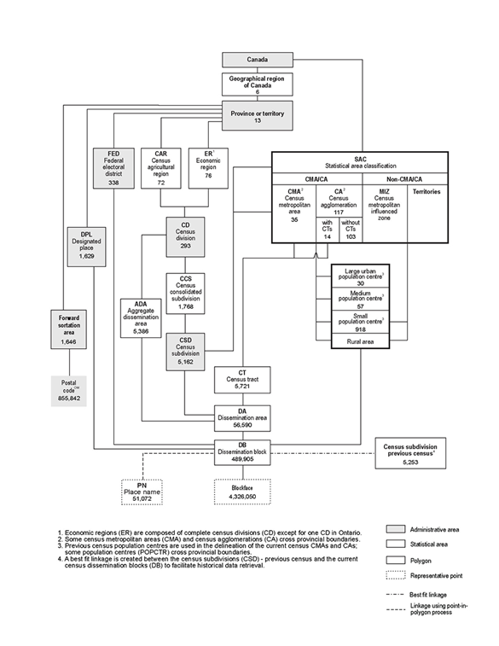

Further Reading
https://www.therecord.com/news/waterloo-region/2021/07/08/puslinch-and-sometimes-cambridge-guelph-or-hamilton-the-ontario-town-with-four-different-addresses.html

https://www.researchgate.net/profile/Russell-Wilkins/publication/323322892_Positional_accuracy_of_geocoding_from_residential_postal_codes_versus_full_street_addresses/links/5a8dfadfaca272c56bc407eb/Positional-accuracy-of-geocoding-from-residential-postal-codes-versus-full-street-addresses.pdf

